**Restaurant Reservation App**

**Mobile App Development**

**Project Proposal**

Subhan Wasif | Aleezae Zia | Fateh Ali Alim

**Project Overview:**

For both iOS and Android platforms, we propose creating a native mobile application that will improve both user experience and interface. One of this application's primary features will be a user-friendly platform for quick registration of new users and effective reservation management. Menu customization is available for dine-in orders, and tableside ordering through contactless and QR codes provides a safer and more productive eating experience. The key features of this application will include:

* **User Registration**: Allow customers to create accounts or profiles with their personal information.
* **Dine-In Order by Table Number or QR Code Scan**: - Provide two methods for customers to initiate orders - either by entering their table number or scanning a QR code at the table.
* **Status Bar Display**: - Display a status bar on the customer's mobile device, indicating the progress of their order, from preparation to serving.

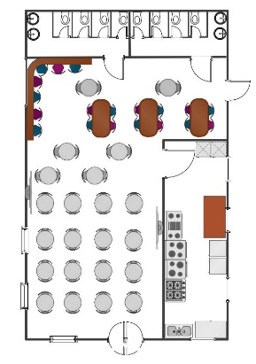

* **Reservation Management**: Enable customers to make reservations for specific dates and time allowing them to pick the specific table they would be seated at (this will be a point of view image of the restaurants layout, similar to how you would book a seat in a cinema), use fig.1 as an example.

Figure.1

* **Dine-In Order at the Restaurant**: Allow customers to place orders for food and drinks when dining in.
* **Menu Customization**: Provide the ability for customers to customize their orders based on preferences or dietary restrictions.
* **Contactless Ordering**: Support contactless ordering through mobile devices to minimize physical contact with staff or menus.
* **Private Function Booking**: Enable customers to select between dining at a regular table or reserving a private room for special events or functions.
* **Pre-Order Feature**: Allow customers to pre-order their meals and drinks if they've already made a reservation.
* **Order Summary Display**: Show a summary of the items ordered, including quantity, price, and special instructions before confirming the order.

**Timeline**

The proposed timeline for this project is as follows:

* Project Kick-off: 13th October
* Design and Development: First two months
* Testing and Quality Assurance: 3 days after development
* Deployment and Launch: 2 days after testing

**UX:**

Experience: To make sure that users of all ages and personality types are catered to by the app.

User-Centric Approach: Customer’s demands and preferences will be kept in mind during the development process in order to create a smooth user experience.

Customization: The app will be created to meet the particular demands and specifications of every restaurant, guaranteeing a solution that is compatible with their operational and business objectives.